Laboratory work report template

discpipline: Computer Architecture

ali Hosseinabadi

Content

# 1 Purpose of work

the goal of this lab is to learn how to format reports using lightweight markdown makeup language.

# 2 Task

-installation of neceserry software

-filling in the laboratory work report no-3 using the markdown markup language

-task for independent work

# 3 Theoretical introduction

Markdown is a lightweight markup language designed to designate formatting in plain text, with maximum human readability, and suitable for machine conversion into languages for advanced publications (HTML, Rich Text and others).

# 4 Laboratory work

In the terminal, I go to the course directory and update the repository from the remote one to GitHub. (fig. 1)

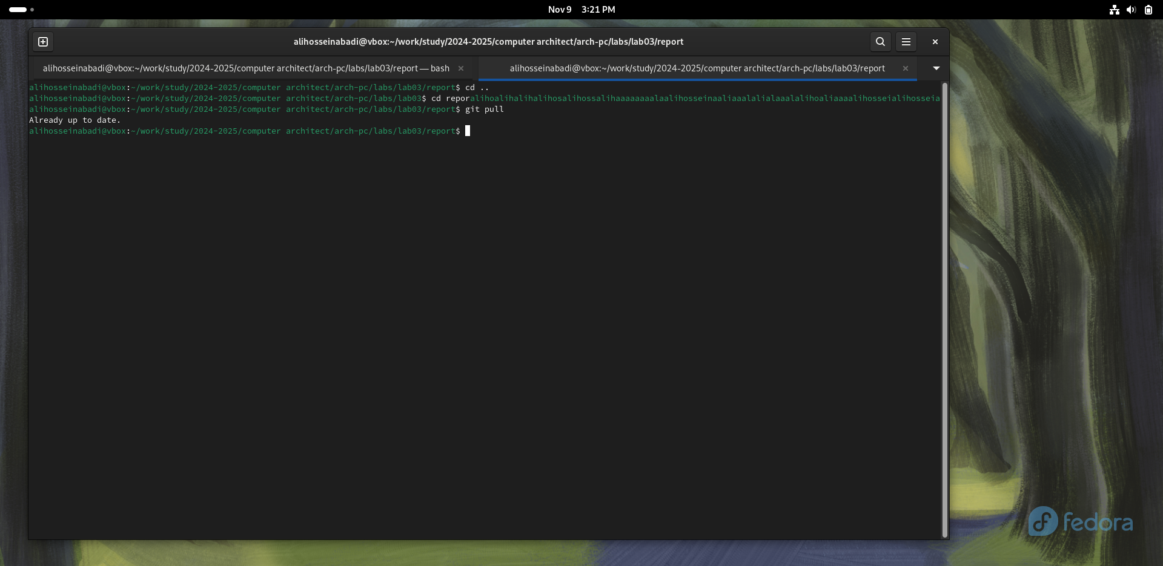

Pic. 1: Updating changes in the course directory

I compile the template using the make command (fig:002), check the correct execution of the command using the ls command (fig. 3)

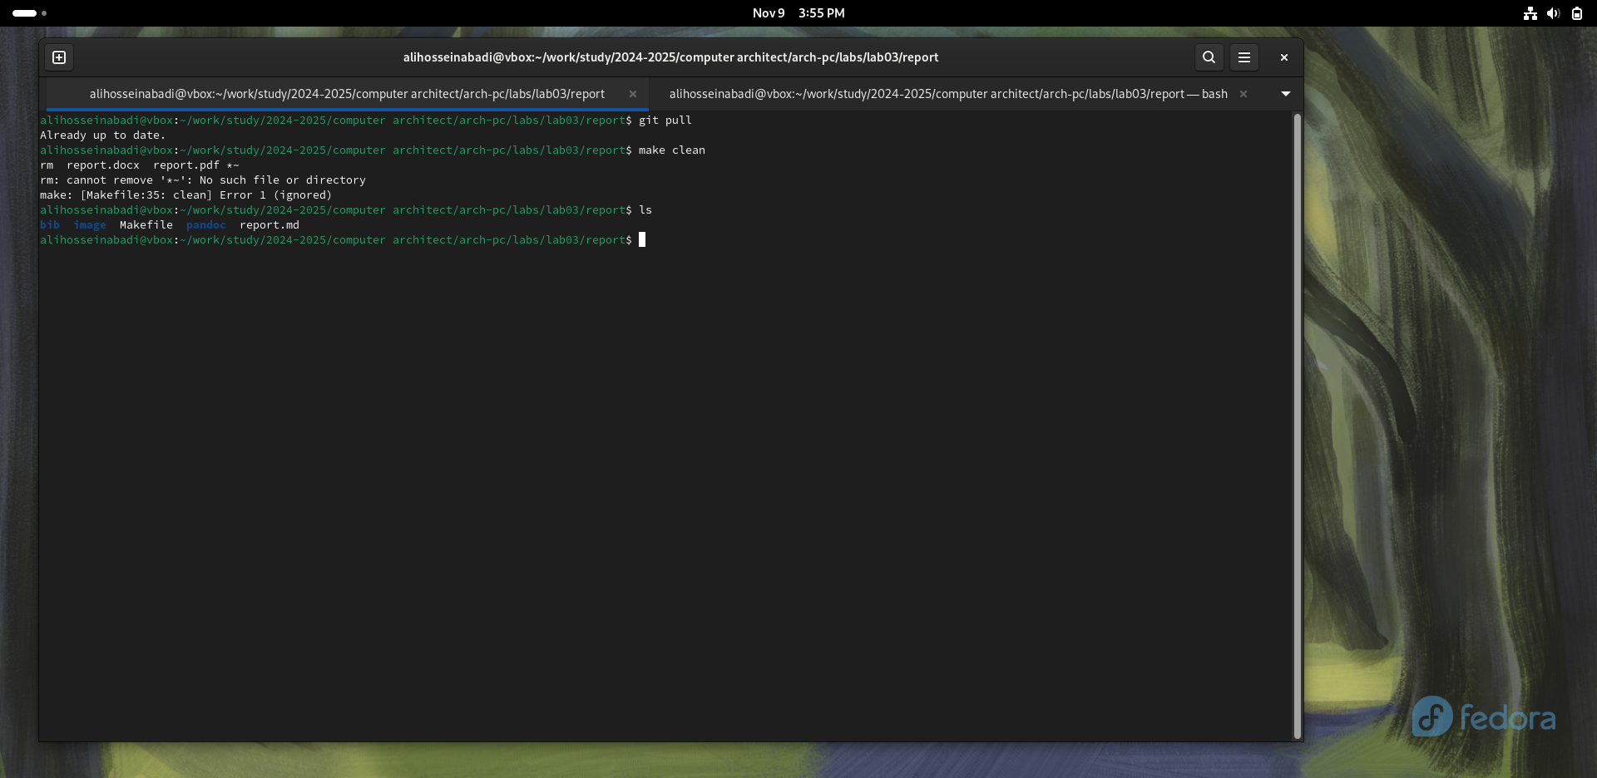

Pic. 2: Compiling the template

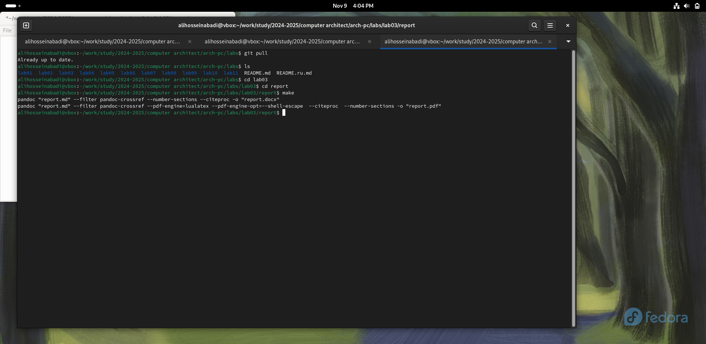

Pic. 3: Checking

After checking the functionality of the template compiler, I delete the generated files using the make clean command (fig. 4)

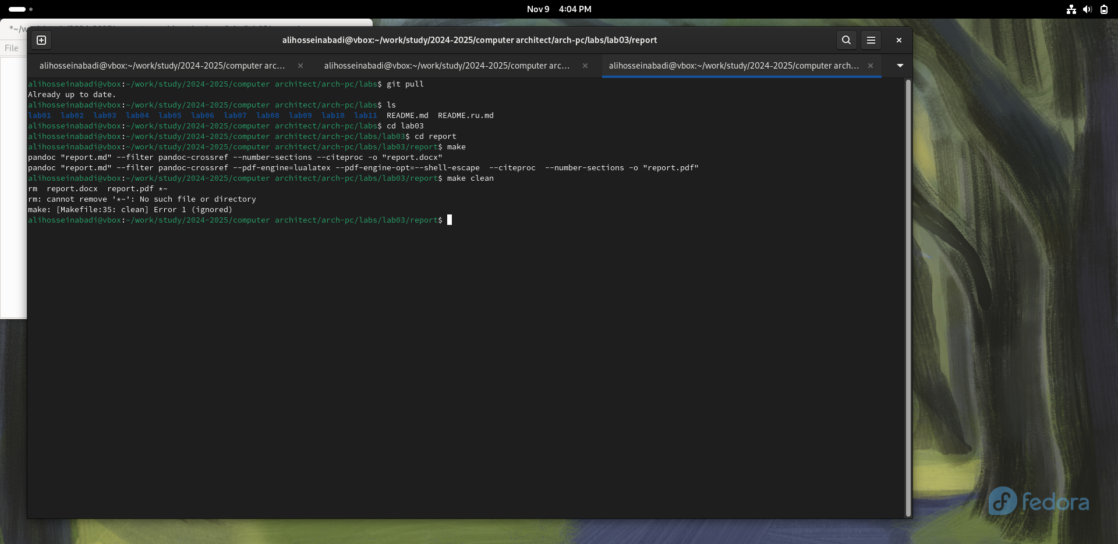

Pic. 4: Deleting generated templates

Using the editor, I run a report on the completed laboratory work (fig. 5)

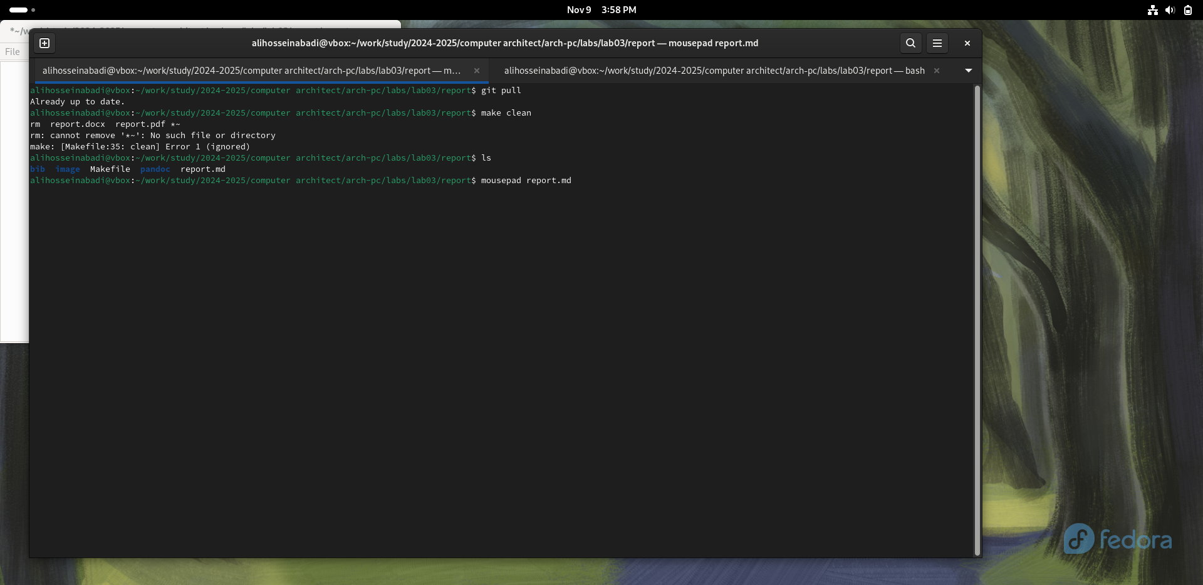

Pic. 5: Preparing the report

# 5 Tasks for independent work

Similarly to completing the report on the current lab, I complete the report in markdown for the second lab, for this I go to the directory of the 2nd lab and prepare the report using the mousepad text editor. (fig. 6)

|  |
| --- |
| Completing the report on the 2nd lab |

Pic. 6: Completing the report on the 2nd lab

# 6 Conclusions

As a result of completing this lab, I mastered the procedures for preparing reports using the lightweight markup language Markdown.

# 7 References

1. [Course on TUIS](https://esystem.rudn.ru/course/view.php?id=112)
2. [Laboratory work No. 3](https://esystem.rudn.ru/pluginfile.php/2089083/mod_resource/content/0/%D0%9B%D0%B0%D0%B1%D0%BE%D1%80%D0%B0%D1%82%D0%BE%D1%80%D0%BD%D0%B0%D1%8F%20%D1%80%D0%20%B0%D0%B1%D0%BE%D1%82%D0%B0%20%E2%84%963.%20%D0%AF%D0%B7%D1%8B%D0%BA%20%D1%80%D0%B0%D0%B7%D0%BC%D0%B5%D1%82%D0%BA%D0%B8%20.pdf) 3 . [Example of lab work](https://github.com/evdvorkina/study_2022-2023_arh-pc/blob/master/labs/lab04/report/%D0%9B04_%D0%94%D0%B2%D0%BE%D1%80%D0%BA%D0%B8%D0%BD%D0%B0_%D0%BE%D1%82%D1%87%D0%B5%D1%82.md?plain=1)